**Appendix 5**

**Test results for running 50,000 time steps with a public goods decay rate of 0.001**

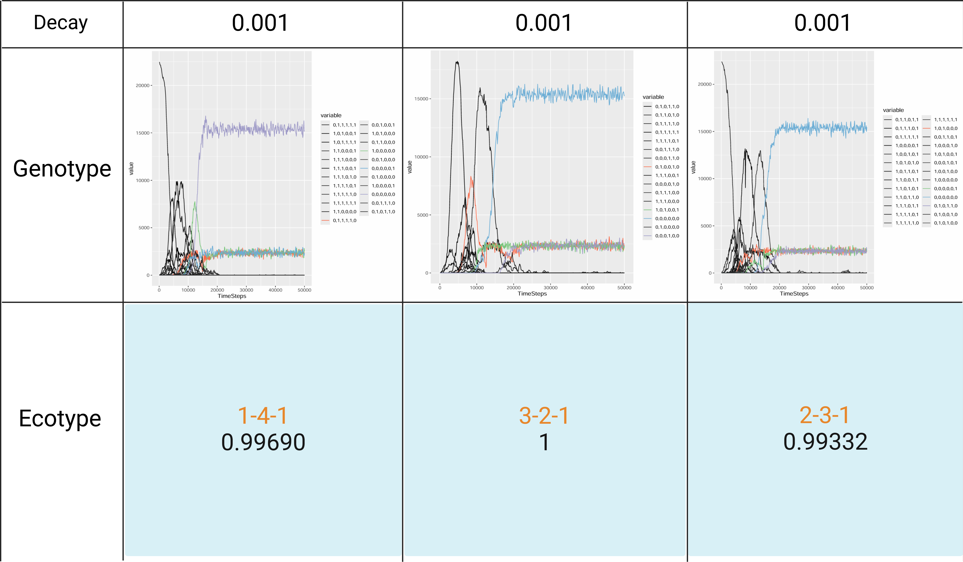

The genotype changes when the public goods decay rate is 0.001, and the ecotype composition at the 50,000th time step. The other parameters are "cost = 0.01", " public goods production interval = 1 ", "public goods diffusion interval = 1", and " public goods decay rates = 0". The removal threshold for the number of genotypes were genotypes with a proportion less than 1. Under the aforementioned parameter combinations, the community can continuously form division of labor within 50,000 time steps and continue to evolve toward Strong Black Queen dynamics. This proves that when secreted metabolites serve as public goods, a public goods decay rate of 0.001 is sufficient to regulate the formation of division of labor among microorganisms within the community.